Application Form Instructions
Applications are due April 29, 2022 by 4pm. Submit to education.award@vch.ca

The application form for the KT Challenge is a separate form, with 8 sections, outlined with brief explanations below. Please keep these instructions nearby when you are completing your application, and carefully read the guidelines for each section.
The Knowledge Translation (KT) Challenge is designed to support teams of PHC, VCH and BC Cancer clinicians who are responsible for moving evidence into practice. The KT Challenge is run in partnership with Providence Health Care Professional Practice, Providence Health Care Research Institute, Vancouver Coastal Health Research Institute, VCH Professional Practice, and the BC Cancer Department of Nursing and Allied Health Research and KT. Funding is provided by PHC, PHCRI, VCHRI, Transplant Research Foundation, and BC Cancer.

Note: Patient Family Partners (PFPs) are key stakeholders for all KT projects. This proposal will be reviewed by the KT Challenge Advisory Committee, which includes a PFP, and also by trained PFP Reviewers. All KT Challenge teams are required and supported to include PFPs in your project work and/or on your project team. Please ask your PFP(s) to sign below in the designated spot on the application form, acknowledging their ongoing contribution and partnership in your project. PFPs will receive two invitations to evaluate their participation over the two years of each funded KT Challenge project.

Page Limit. Please limit the entire application to five pages, 12-point font, double-spaced. Page count begins with Lay Summary.

Section 1 – Lay Summary. Please begin your proposal with a lay summary of your project. Use plain language that all reviewers of the proposals can understand. Note that not all reviewers are clinicians or experts in your area of clinical practice. For example, you could write, “Because patients with cardiac disease are known to be at high risk for depression, and because untreated depression leads to negative health outcomes, we propose to implement the use of a validated depression screening tool in the inpatient cardiac program at St Paul’s Hospital. We will identify champions among the key stakeholders (nurses and physicians), offer short training sessions, and use Plan Do Study Act cycles to test and modify intervention strategies. We will evaluate our intervention by chart audits to check whether screening was completed, and use follow-up phone calls with patients regarding conversations about depression screening they may have had with their primary care provider following their hospitalization.”

Section 2 – Need and Evidence Base. You can cut and paste content directly from your LOI into this section, or modify this content based on learnings from the workshop, readings from the Learning Hub site, or feedback from the review committee. In this section you will need to describe the practice change you wish to implement, explain the need for the practice change, and provide brief overview of the evidence base that demonstrates that the practice change will address the need identified.

Section 3 – Implementation Strategies. In this section, you will need to describe the implementation strategies you will use. Use the information you collected on stakeholder needs, barriers, facilitators, what you know about effective implementation strategies, and what will work with your stakeholders. As you learned in Workshop #1, the selection of implementation strategies is based on:
- the needs and contexts of the stakeholders involved or affected by your practice change
- the barriers and facilitators to adopting the practice change, and
- the research evidence on effective implementation strategies.

Incorporate Info from Worksheets. Include information from your completed Stakeholder Engagement Worksheet and your completed Barriers and Facilitators Worksheet. Please integrate the information from the worksheets into your proposed implementation strategies and also attach the completed worksheets to your application as appendices. (Stakeholder Engagement, Barriers and Facilitators,) Note: The worksheets are explained in Workshop #1. Between Workshop #1 and Workshop #2, you are expected to complete these worksheets, submit them by January 28, and meet with at least one of your stakeholder groups. You will receive feedback on the worksheets you submitted in January, and this feedback should be incorporated into your final proposal.

Provide Evidence and Cite Literature. Look into the literature on implementation strategies and propose the most effective implementation strategies to achieve your practice change. Include references to published literature (when available) and/or contextual factors that influenced the section of the implementation strategies you propose to use.

Section 4 -- Evaluation Plan. In this section, you will describe how you will evaluate the impact of your practice change, based on information and worksheets provided in Workshop #2.
Be sure to include:
- The questions your evaluation will answer making sure to include a question assessing the uptake of the practice change.
- A logic model that shows the implementation activities and the intended outcomes that are expected to result from your practice change (attach your logic model as an appendix). You may adapt one of the logic model examples provided by Marla at Workshop #2 or create your own.
- The data collection plan including how you will assess uptake of the practice change
The evaluation plan should be limited to 2 pages and should be in narrative form referencing your logic model and the data collection template presented in Workshop #2 (Please include these as Appendices).

Section 5 -- Work plan and Dissemination Plan. In this section, please provide your work plan with timeline, a dissemination plan for sharing findings of your project, and some ideas on how you will sustain the practice change after your project is complete.
Be sure to include:
- Project timelines
- Where and when you plan to present your results

Section 6 – Budget. Outline the total proposed budget in the tables below. Funds may be used to pay:
- Buy-out time for regular PHC, VCH or BC Cancer staff to work on the KT Challenge project
- Salaries for research assistants and administrative, transcribing or translating services
- Computing services or software site licenses, for small equipment, usually less than $100
- Supplies and services, such as office supplies and printing
In the personnel table provided on the application form, list all personnel involved in the project, whether being paid from project funds or not. If not to be paid from project funds, put N/A in the last two columns.
Section 7 – Mentor’s Contribution. We require that teams meet with their mentor to develop the funding proposal, develop an appropriate timeline and ensure their proposal is ready for submission. Ask your mentor to fill in this part of the application.
Section 8 – Patient Family Partner Contribution. Ask your PFP to fill in this part of the application, noting ways they have contributed and will continue to assist by advising your project team.

Three of the application sections correspond to the three pillars of implementation planning:
Pillar 1 – Demonstrate the need for the practice change
Pillar 2 – Select the implementation strategies to support the practice change
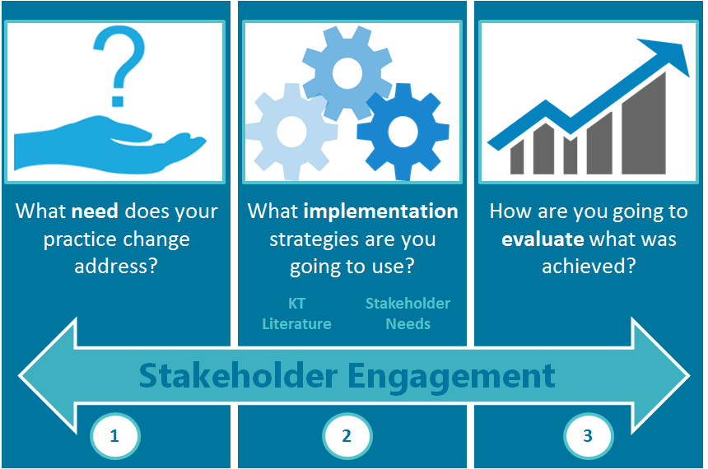
Pillar 3 – Develop the evaluation plan to determine whether your practice change was successful in achieving your improvement. Note: Pillar 3 is key, as your measurement of practice change is an essential element of the KT Challenge.

