**Letter of Intent - LOI Examples**

"Knowledge translation is the art and science of moving evidence into health care policy and practice"

The Knowledge Translation (KT) Challenge is designed to support teams of Providence Health Care, Vancouver Coastal Health, BC Cancer, Northern Health, and Fraser Health clinicians (nursing, allied health, and medical staff) who want to move evidence into practice. The KT Challenge is offered and supported by these five organizations.

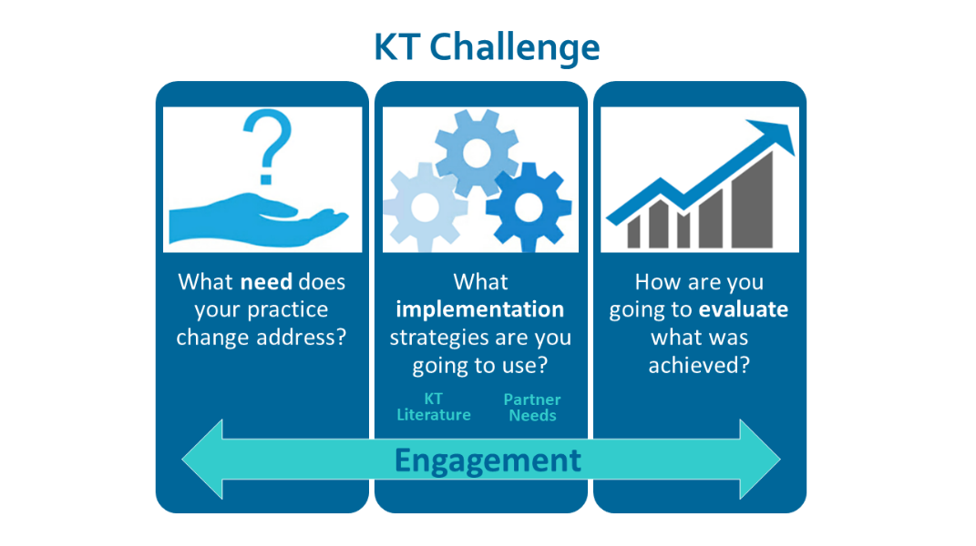

To begin the KT Challenge application process, please complete and submit a Letter of Intent (LOI) by October 17, 2025 at 4:00 pm.

After the letters are reviewed and if your team is accepted to participate in the KT Challenge, teams will be required to meet with their organization’s KT Challenge Lead to discuss their project between November 10–28, 2025, and attend scheduled workshops on the following dates:

Workshop #1 – December 4, 2025, Time: 9:00 am – 11:00 am

Workshop #2 – January 29, 2026, Time: 9:00 am – 11:00 am

Workshop #3 – February 26, 2026, Time: 9:00 am – 11:00 am

Note: Participants will be required to view and complete some preparatory activities before and after attending these workshops.

The following page has examples to help teams prepare their Letter of Intent for the KT Challenge.

**Writing your Letter of Intent - Examples**

Your LOI should describe the practice change you would like to implement and briefly present the evidence that shows that this change will bring value to your area of practice. **(250-word maximum).**

**1)** Include a short and informative title for your project.

**2)** Clearly and succinctly describe the practice change you wish to implement.

|  |
| --- |
| Examples:  — “We are going to conduct a medication management assessment on all patients at intake in one hospital.”  — “We are going to implement the use of a validated screening tool for depression for all cardiac patients in one hospital.” |

**3)** Briefly explain the need or impetus for this practice change citing evidence from the location where this practice change will take place.

|  |
| --- |
| Example:  — “Though harm reduction practices have been supported and implemented in acute psychiatry, concerns over utilization continue to be observed and expressed. Chart audits show that less than 20% of patients receive information on harm reduction and 49% of staff report not feeling confident in engaging patients in harm reduction conversations.” |

**4)** Provide a brief overview of the evidence-base for the practice change. Include any published research or evidence that shows your practice change will effectively address the need you have identified.

|  |
| --- |
| Example:  — “The Canadian Pediatric Association developed a guideline for skin-to-skin contact during invasive procedures in 2017. This guideline has not been implemented in our NICU and this practice change will support the implementation of this guideline. Evidence shows that skin-to-skin contact during invasive procedures results in less stress for infants and parents, and more favourable outcomes.” |