Application Form – Team Information
Due April 23, 2020

The Knowledge Translation (KT) Challenge is designed to support teams of PHC and VCH clinicians who are responsible for moving evidence into practice. The KT Challenge is run in partnership with Providence Health Care Professional Practice, Providence Health Care Research Institute, Vancouver Coastal Health Research Institute (VCHRI) and VCH Professional Practice and is supported by funding from PHC, PHCRI and VCHRI.

Project Title:
Team Lead Information
Name: Click here to enter text. | Position/Title: Click here to enter text.
Email: Click here to enter text. | Phone (work): Click here to enter text.
Site/Unit: Click here to enter text. | Signature*:
Team Members’ Information
Name #1: Click here to enter text. | Position/Title: Click here to enter text.
Email: Click here to enter text. | Phone (work): Click here to enter text.
Site/Unit: Click here to enter text. | Signature*:
Name #2: Click here to enter text. | Position/Title: Click here to enter text.
Email: Click here to enter text. | Phone (work): Click here to enter text.
Site/Unit: Click here to enter text. | Signature*:
Name #3: Click here to enter text. | Position/Title: Click here to enter text.
Email: Click here to enter text. | Phone (work): Click here to enter text.
Site/Unit: Click here to enter text. | Signature*:
*By signing above, you agree to communicate with the organizing committee any changes to your team or your participation, to complete the online KT Challenge evaluation surveys and to encourage all your team members to complete the surveys.
Manager Support
By signing, I acknowledge that I have discussed this practice change with the team leader and agree to support them in this project. If this project is funded I will work with the team members to accommodate requests for scheduled time to work on this project.
Manager Name: Click here to enter text. |  | Position/Title: Click here to enter text.
Email: Click here to enter text. |  | Signature:
Agreement between Team Members and KT Challenge Organizing Committee
If you are accepted for participation in the KT Challenge, the organizing committee agrees to work with you to select a mentor for your project and provide KT skills workshops. If your project is funded, we will support you to conduct your KT project.

Application Form. The KT Challenge Application Form is designed to allow you to provide the information required to successfully support the planning, implementation, and evaluation of evidence-based practice improvements. It includes sections that correspond to the three pillars of implementation planning:
Pillar 1 – Demonstrate the need for the practice change (Section 1 of the application, similar to the information you provided in your LOI)
Pillar 2 – Select the implementation strategies to support the practice change (Section 2 of the application)
Pillar 3 – Develop the evaluation plan to determine whether your practice change was successful in achieving your improvement (Section 3 of the application).

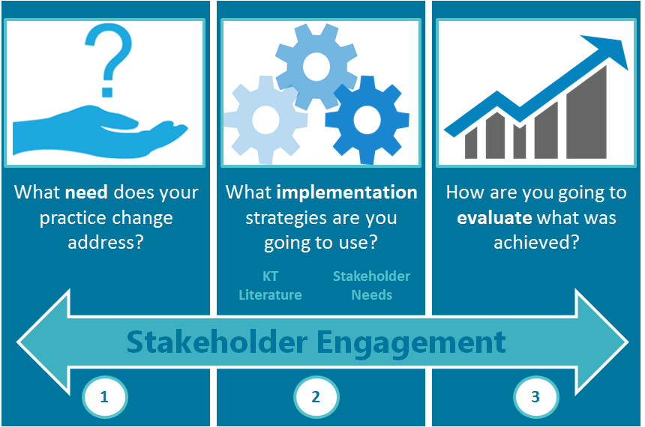

Application Form – Section 1 – Demonstrate the need for your proposed practice change

Describe the practice change you would like to implement and briefly present the evidence that shows that this change will bring value to your area of practice. (250-word maximum for Section 1)
Please make sure to:

- Include the title of your project
- Briefly describe the practice change you wish to implement (e.g., “we are going to implement a palliative approach with all patients in one unit”; OR, “we are going to conduct a medication management assessment on all patients at intake in one hospital”; OR, “we are going to implement the use of a validated screening tool for depression for all cardiac patients in one hospital.”)
- Briefly explain the need or impetus for this practice change.
- Provide a brief overview of the evidence-base for the practice change (i.e., the published research or evidence that shows your practice change will effectively address the need you have identified). For example, you might say, “The Canadian Pediatric Association developed a guideline for skin-to-skin contact during invasive procedures in 2017. This guideline has not been implemented in our NICU and this practice chance will support the implementation of this guideline. Evidence shows that skin-to-skin contact during invasive procedures results in less stress for infants and parents and more favourable outcomes.”
Section 1 - Demonstrate the need for your proposed practice change
Title of your project:

Briefly describe the practice change you wish to implement:

Briefly explain the need for this practice change:

Provide a brief overview of the evidence base that demonstrates that the practice change will address the need identified:

Application Form – Section 2 – Describe the proposed implementation strategies

As you learned in Workshop #1, the selection of implementation strategies is based on:
- the needs and contexts of the stakeholders involved or affected by your practice change
- the barriers and facilitators to adopting the practice change, and
- the research evidence on effective implementation strategies.

Section 2 is the heart of your proposal. Use the information on stakeholder needs, barriers, facilitators, what you know about effective implementation strategies, and what will work with your stakeholders, to describe the implementation strategies you will use.

Lay Summary. Please begin this section with a lay summary of your project. Please use plain language that all reviewers of the proposals can understand. Note that not all reviewers are clinicians or experts in your area of clinical practice. For example, you could write, “Because patients with cardiac disease are known to be at high risk for depression, and because untreated depression leads to negative health outcomes, we propose to implement use of a validated depression screening tool in the inpatient cardiac program at St Paul’s Hospital. We will identify champions among the key stakeholders (nurses and physicians), offer short training sessions, and use Plan Do Study Act cycles to test and modify intervention strategies. We will evaluate our intervention by chart audits to check whether screening was completed, and using follow-up phone calls with patients regarding conversations about depression screening they may have had with their primary care provider following their hospitalization.”

Incorporate Info from Worksheets. Include information from your completed Stakeholder Engagement Worksheet and your completed Barriers and Facilitators Worksheet. Please integrate the information from the worksheets into your proposal below, and also attach the worksheets to your application as appendices. Note: The worksheets are explained in Workshop #1. Between Workshop #1 and Workshop #2, you are expected to complete these worksheets, submit them by January 31, and meet with at least one of your stakeholder groups.

Provide Evidence and Cite Literature. Look into the literature on implementation strategies and propose the most effective implementation strategies for your project. Include references to published literature (when available) and/or contextual factors that influenced the section of the strategies you propose to use.

Page Limit. Please limit this section to four pages, 12-point font, double-spaced.

Click here to enter text.

Lay Summary (200 words):

Summary of Stakeholder Engagement:

Summary of Barriers and Facilitators:

Implementation Plan:

Application Form – Section 3 – Evaluation Plan

In this section, describe how you will evaluate the impact of your practice change, based on information and worksheets provided in Workshop #2.
Be sure to include:
- The questions your evaluation will answer
- A logic model that shows the implementation activities and the intended outcomes that are expected to result from your practice change (attach your logic model as an appendix). You may adapt one of the logic model examples provided by Marla at Workshop 2 or create your own.
- The data collection plan
The evaluation plan should be limited to 2 pages and should be in narrative form referencing your logic model and the data collection template presented in Workshop #2 (Please include these as Appendices).

Click here to enter text.

Application Form – Section 4 - Timeline
In this section, please provide your work plan with timeline, a dissemination plan for sharing findings of your project, and some ideas on how you will sustain the practice change after your project is complete.
Be sure to include:
- Project timelines
- Where and when you plan to present your results
- How you plan to sustain the practice change and results achieved once the project is completed.

Click here to enter text.

Application Form – Section 5 - Budget

Outline the total proposed budget in the tables below. Funds may be used to pay:
- Buy-out time for regular PHC and/or VCH staff to work on the KT Challenge project
- Salaries for research assistants and administrative, transcribing or translating services
- Computing services or software site licenses, for small equipment, usually less than $100
- Supplies and services, such as office supplies and printing
In the personnel table below, list all personnel involved in the project, whether being paid from project funds or not. If not to be paid from project funds, put N/A in the last two columns.

Personnel Budget
Name | Title & Project Contribution |  |  | Time Allocated | Salary |  | Estimated Expenditure
Subtotal:
Equipment Budget
Item |  |  | Justification |  | Estimated Expenditure
Subtotal:
Services Budget
Item |  | Justification |  |  |  | Estimated Expenditure
Subtotal:
Total Estimated:

Application Form – Section 6

By signing below, the Manager or Supervisor acknowledges that they (please check):
Had a discussion with team members regarding the time and resource expectations of the implementation plan
Read through the completed application form, including the team information sheet
Confirm that they will support this team as outlined in this application

Operations Leader, immediate Manager or Supervisor
Name |  |  | Signature
Title/Department
Facility/Site
Telephone |  | Email

Application Form – Section 7

Mentor Contribution

We recommend that teams meet with their mentor to develop the funding proposal, develop an appropriate timeline and ensure their proposal is ready for submission.

Please ask the mentor for your project to briefly describe their contributions to the project and proposal, as well as their anticipated contributions in conducting the knowledge translation project, if your project is funded. You may cut and paste a note below, or attach a note to this proposal.

- As the mentor for this project, I contributed in the following ways to the development of this proposal:

- As the mentor for this project, I anticipate contributing in the following ways if the project is funded:

By signing below, the Mentor acknowledges that they (please check):
Had input into the design of the knowledge translation project described in this application
Read through the completed application form, including the team information sheet
Confirm that they will support this team as outlined in this application

Mentor
Name |  |  | Signature
Title/Department
Facility/Site
Telephone |  | Email

Team Members – Extra Space Signature
Team Member Name
Date
Signature
Team Member Name
Date
Signature
Team Member Name
Date
Signature
Team Member Name
Date
Signature
Team Member Name
Date
Signature

For information or assistance in filling out this form, please contact: Aggie Black ABlack@providencehealth.bc.ca) or Amanda Chisholm (education.award@vch.ca)

Application Form (Sections 1-7) due: April 23, 2020 at 4:00pm
Submit via email to education.award@vch.ca

